JUDICIAL NOTICE OF ADMINISTRATIVE DEFAULT AND ESTOPPEL
THE ECUMENICAL AND ECCLESIASTICAL COMBINED COURTS (EECC)

DIVISION FOUR – COURT OF RECORDS AND ROYAL REGISTRY
REGISTRY ENTRY ID: KRA-ENTRY-CRN-AUTH-USA-2026-002
CERTIFICATE OF ADMINISTRATIVE DEFAULT AND ESTOPPEL BY ACQUIESCENCE

CASE REF: CRN-NOTICE-USA-2026-001
THE COURT HEREBY FINDS:

That formal Notice of Sovereignty, Claim of Right, and Specific Territorial Holdings (encompassing several thousands of acres of Sovereign Land Estates) was duly served upon the United States Government on [Insert Date of Original Service].

That the allotted time for a verified rebuttal or lawful contestation has expired.
That no rebuttal, contestation, or denial of the facts presented has been received by this Court or the Royal Treasury.

THEREFORE, IT IS DECREED:

That the United States Government is in Administrative Default. Under the laws of nations and the maxims of equity, the United States is ESTOPPED from denying the sovereignty of the Kingdom of David, its title to the California Mineral and Water Estates, and the validity of its Monetary Acts. This Default constitutes Tacit Recognition of the Kingdom of David as a Sovereign Power.

SO ORDERED, ADJUDGED, AND DECREED this 13th day of March, 2026.
Attested: Clerk of Court, EECC, Division Four
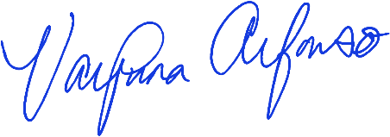

____________________________________ /L.S./
Vaipuna Alfonso
Presiding Clerk — Office of the Clerk,
The Ecumenical and Ecclesiastical Combined Courts
Date of Certification: March / 13 / 2026

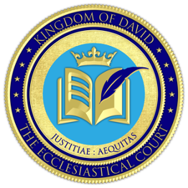
[CLERK OF COURT SEAL] [COURT SEAL]

[Rest of this Page is Intentionally Left Blank]

ROYAL ACKNOWLEDGMENT AND PROMULGATION
I, His Majesty King David Joel, Crown Sovereign of the House and Kingdom of David, having duly reviewed all the evidentiary evidence that the United States Government is in Administrative Default and this Notice of Estoppel to the United States of America, do hereby acknowledge, confirm, and promulgate the same under Royal Seal as an instrument of record for the Kingdom, to be entered into the Internal Kingdom Library (IKL) and the Kingdom Registry of Instruments.
Royal Signature Block
His Majesty, Crown Sovereign of the House and Kingdom of David.
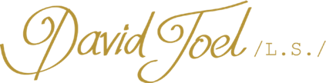
__________________________________
His Majesty King David Joel
Crown Sovereign of the House and Kingdom of David
Minister of the International Bank of Issue
Under Royal Seal and Authority of the Covenant of Formation
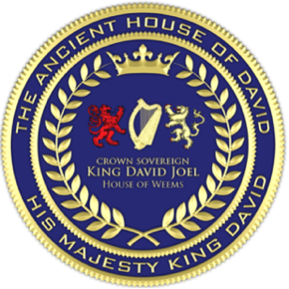
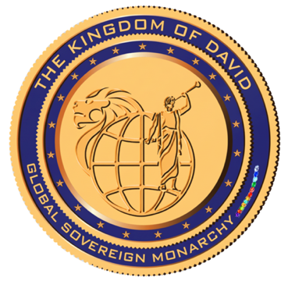
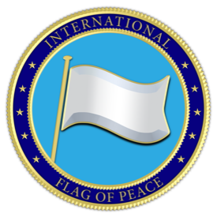

[INTERNATIONAL FLAG OF PEACE] [CROWN SOVEREIGN SEAL] [GREAT SEAL OF THE KINGDOM]

