THE HOUSE AND KINGDOM OF DAVID
MASTER INDEX OF DIPLOMATIC INSTRUMENTS

Office of the Crown Sovereign
Foundational Authority
Apostolic Preface to the Four Pillars
Doctrine of the Threefold Witness
The Royal Charter for Angelic Intelligence (Pillar One)
Royal Gold Crown White Paper (Pillar Two)
Royal Proclamation of Sanctuary, Peace, and Prosperity (Pillar Three)
Sovereign World Notice (Pillar Four)
Revised Royal Constitution (Final 2026 Revision, not included the full Royal Constitution can be read on the Website www,hodkod.org)

Foundational Maxim of Sovereign Mandate: The Kingdom of David, established by God, and upheld by an eternal and continuing mandate does not seek permission from earthly authorities, but proclaims its mandate and extends invitation to the nations of its peaceful intent to restore the land and its people.

DIPLOMATIC PACKET STRUCTURE (TAB INDEX)
The following structure defines the organization of the Primary Diplomatic Packet as transmitted:
FRONT MATTER
1. Executive Cover Sheet
2. Master Administrative Estoppel Summary & Index (MAESI)
3. Master Index of Diplomatic Instruments (MSTR IDO)
4. Recipient / Service Matrix
5. Primary Diplomatic Transmittal Instrument (PDTI)
6. Notice of Complete Administrative Record
7. Certificate of Service

TABBED ENCLOSURES

TAB 1 — Notice of Successorship and Correction of Record
• Notice of Successorship and Correction of Record (SCR-EECC-2026-0015)
TAB 2 — Proposed Treaty of Peace, Prosperity, Commerce, and Civilization
• Proposed Treaty of Peace, Prosperity, Commerce, and Civilization
TAB 3 — Foundational Authority (Referenced and/or Excerpts)
• Apostolic Preface to the Four Pillars
• Doctrine of the Threefold Witness
• (Covenant of Formation — Incorporated by Reference)
• (Royal Constitution — Incorporated by Reference)

TAB 4 — Four Pillars and Charter Frameworks
• Royal Charter for Angelic Intelligence
• Royal Gold Crown White Paper
• Royal Proclamation of Sanctuary, Peace, and Prosperity
• Sovereign World Notice

TAB 5 — Monetary Activation and Treasury Instruments
• Royal Monetary Activation Order
• Royal Treasury Act
• Royal Proclamation — Angelic Intelligence Database

TAB 6 — Final Disposition and Judicial Closure
• Notice of Final Disposition
• Supporting Judicial Notices (if applicable)

TAB 7 — Administrative Record & Status Verification
• Notice of Complete Administrative Record
• Certificate of Good Standing — House and Kingdom of David

TAB 8 — Proof of Service and Delivery Record
• USPS Receipts
• Tracking Confirmations
• Delivery Acknowledgments

Monetary Governance and Assets
Royal Treasury Act of 2026
Royal Monetary Activation Order
Kingdom Registry of Instruments (Verified Asset Schedule)
Royal Gold Crown Prospectus
Crown Custodial and Audit Covenant

Judicial Authority and Administrative Record
Perfected Administrative Estoppel (Closed Record Statement)
EECC Judicial Notice of Treaty Level
Notice of Supplemental Authority (Expanded Jurisdiction)
EECC Judicial Notice of Administrative Default

Diplomatic Engagement
Proposed Treaty of Cooperation between the Kingdom and the United States
Angelic Intelligence Database (AID) Diplomatic Interface Framework

[Signature and Seal are on the Next Page]

SO DECREED AND ENACTED by His Majesty King David Joel, Crown Sovereign of the House and Kingdom of David, under Royal Seal, as of this Thirtieth Day of May, in the Year of Our Lord 2026.
By Royal Prerogative – His Majesty King David Joel

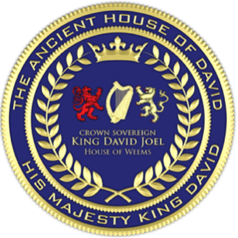
__________________________________
His Majesty King David Joel
Crown Sovereign of the House and Kingdom of David


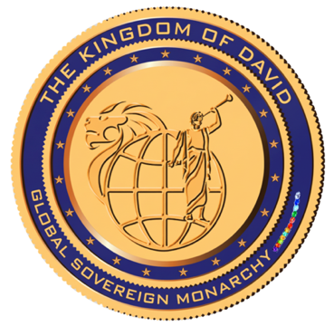

Clerk's Certification and Attestation
INSTRUMENT: MASTER INDEX OF DIPLOMATIC INSTRUMENTS  NO: RC-EECC-2026--0209  JURISDICTION: EECC | STATUS: FORMAL RECORD  CRN: 2026-EECC-022026O209
I, Vaipuna Alfonso, Presiding Clerk of the Ecumenical and Ecclesiastical Combined Courts, do hereby certify and attest that:
One. This official file entitled Master Index of Diplomatic Instruments has been duly issued under the authority and Royal Prerogative of His Majesty King David Joel, Crown Sovereign of the House and Kingdom of David;
Two. This instrument operates under the authority and jurisdiction of the Twelve Combined Courts structure, as formally ratified and confirmed by Royal Sovereign World Notice RC-EECC-2026-012-A;
Three. This instrument has been properly entered and recorded in the Kingdom Registry of Instruments under Court Record Number CRN: 2026-EECC-0220260209;
Four. This instrument is recorded as official within the Division Four Court of Records of the Ecumenical and Ecclesiastical Combined Courts and is complete, in force, and binding upon all parties noticed herein.
Vaipuna Alfonso Presiding Clerk — Office of the Clerk, The Ecumenical and Ecclesiastical Combined Courts

__________________________ /L.S./
Vaipuna Alfonso Presiding Clerk —
Office of the Clerk, the
Ecumenical and Ecclesiastical Combined Courts

Date of Certification: May / 30 / 2026

