SOVEREIGN ECONOMIC DEVELOPMENT COMMISSION
(Instrumentality Supported by the Royal Treasury of the House and Kingdom of David)
1. PUBLIC-FACING PHILOSOPHY
“The Kingdom Economy of Benevolent Increase”
(For Website, D’Vida Living Society, and SGEDC Pages)
The House and Kingdom of David is founded on a simple but powerful truth found in Scripture:
God gives power to gain wealth, and He calls His people to use that power for benevolent good.
This principle is beautifully demonstrated in the second letter to the Corinthians, where the Apostle Paul organized what may be the earliest divinely-inspired economic system. The poorest believers gave from the heart, the funds were entrusted for wise stewardship, and instead of being spent instantly, the money was invested so it could grow into a perpetual source of benevolent support.
From this pattern, the Kingdom of David has built a modern version of that same principle — a Kingdom Economy of Benevolent Increase.
What this means:
- We do not simply hand out money.
- We create systems that become self-funding.
- We build structures that grow year by year.
- We ensure that every citizen has a benevolent foundation that increases with the Kingdom.
- We protect the poor without creating dependency.
- We empower citizens without burdening future generations.
Through the Royal Crown – Individual Benevolent Trust (RC-IBT) system, each citizen receives:
- A benevolent trust established in their name
- An annual benevolent distribution in Royal Crowns
- A share in the annual increase of the Kingdom’s benevolent foundations
- A lifelong benefit that grows over time
This is not charity — this is Kingdom stewardship, built on the same model God revealed through His apostles.
As the Kingdom builds, develops land, expands its operations, and increases its economic footprint, the benevolent foundations grow as well — creating a cycle of increase, blessing, and restoration that honors God and empowers His people.
This is the economy of the restored Booth of David.
Not an economy of consumption, but an economy of covenant, stewardship, and increase.

2. ROYAL FINANCIAL DOCTRINE
“The Doctrine of Benevolent Increase”
(For Teaching, Internal Education, New Ministers, and Treasury Officers)
I. Foundational Scripture
The Royal Financial Doctrine of the Kingdom of David is established upon:
- 2 Corinthians 7–10 – the Macedonian–Corinthian trust system
- Deuteronomy 8:18 – “It is God who gives you power to get wealth”
- Proverbs 13:22 – “A good man leaves an inheritance to his children’s children”
- Acts 11:29–30 – benevolent giving administered through appointed trustees
- Psalm 127:1 – “Except the LORD build the house”
- Amos 9:11 – the restoration of the Booth of David
Scripture reveals that God desires not momentary charity but systems of increase, built and administered in righteousness.
II. The Macedonian–Corinthian Pattern
Paul created a benevolent system that:
- Received contributions from the poor (Macedonia)
- Entrusted the funds to a trustee (Paul)
- Directed the funds to a financial center (Corinth)
- Invested them long-term
- Allowed the fund to grow
- Distributed the increase to support believers
- Ensured the fund never collapsed
- Created a perpetual benevolent resource
This is the earliest biblical model of a trust-based benevolent economy.
III. The Kingdom of David Application
The Kingdom replicates this divine model through:
1. Royal Crown – Individual Benevolent Trusts (RC-IBTs)
Each citizen receives a trust structure funded by the Kingdom for benevolent support.
2. Self-Sustaining Benevolence
The Kingdom does not embrace one-time charity. Instead, it builds systems that:
- grow
- compound
- increase
- and become perpetual sources of benevolence
3. Annual Increase
Each RC-IBT participates in:
- Annual benevolent distributions
- Annual trust value increases
- Long-term Kingdom-wide growth
4. Citizen Equity in the Kingdom’s Future
Every citizen shares in:
- the increase of lands
- the development of communities
- the productivity of industry
- the expansion of benevolent wealth
This creates a nation of stewards, not dependents.
IV. The Doctrine Defined
This Doctrine can be summarized in six pillars:
- God gives power to gain wealth.
Wealth is a tool of restoration, not domination.
- Wealth must be governed by trustees in righteousness.
(Paul was trustee of the Macedonian fund.)
- Benevolence must be self-sustaining.
One-time gifts dry up; properly managed trust systems grow.
- Citizens must share in the increase of the Kingdom.
A covenant community rises together.
- The principal must be preserved.
Distributions come from growth, not depletion.
- The booth of David is restored through stewardship.
Economic stability is part of covenant restoration.
This is the Financial Doctrine of the Kingdom of David, to be taught and upheld across all ministries, divisions, and generations.

3. INTERNAL TREASURY WHITE PAPER
“THE RC-IBT SYSTEM AS A SOVEREIGN BENEVOLENT ASSET ARCHITECTURE”
(For Internal Treasury, ABLE, SGEDC, Ministers of Finance, and Global Bank & Trust)
Executive Summary
The RC-IBT system is the Kingdom’s sovereign benevolent asset architecture, ensuring perpetual and increasing financial support for citizens while simultaneously strengthening the Royal Treasury.
It is inspired by the Macedonian–Corinthian financial model administered by Paul and translated into a modern sovereign trust framework.
System Architecture Overview
1. Trust Vehicle (RC-IBT)
Each RC-IBT is a sovereign benevolent trust established under the:
- Royal Crown Master Trust Indenture
- Ministry of Alpha Benefit Life Endowment (ABLE)
- Oversight of the Royal Treasury
It provides benevolent distributions based on trust value.

2. Funding Mechanisms
RC-IBTs may be funded through:
- Single-Pay Benevolent Annuity Contracts
- Royal Treasury allocations
- Annual Kingdom increases
- Additional benevolent contributions approved by Decree
3. Growth Mechanisms
Each RC-IBT participates in:
- Mandatory annual 5% benevolent distribution
- Annual principal increase from Kingdom-wide benevolent allocation
- Pro-rata share of net income from designated mining, rare earth, and development initiatives
- Compounded benevolent growth over time
4. Treasury Integration
The Treasury may:
- Aggregate RC-IBTs into standardized blocks (e.g., 100M value blocks)
- Utilize them as sovereign backing instruments
- Issue gold-backed Royal Crown currency against consolidated benevolent reserves
- Increase sovereign liquidity without diminishing trust principal
This allows the Treasury to:
- Expand benevolent capacity
- Fund infrastructure
- Stabilize currency
- Support economic development
- Maintain long-term sovereign solvency
5. Risk Management
Key internal policies include:
- Preservation of trust principal
- Pro-rata allocation to prevent imbalance
- Mandatory reporting to SGEDC and ABLE
- Evaluation of annual trust growth rates
- Compliance with Royal Constitution and Royal Treasury Codes
6. Expected Outcomes
The RC-IBT system is expected to:
- Grow cumulatively year by year
- Expand the benevolent footprint of the Kingdom
- Increase annual distributions to citizens
- Strengthen sovereign financial stability
- Support industrial, territorial, and humanitarian development
- Become the primary benevolent engine of the Kingdom economy
Conclusion
The RC-IBT system is not an expense — it is a sovereign asset class and a benevolent capital engine.
It simultaneously:
- blesses citizens,
- strengthens the Kingdom,
- expands the Treasury, and
- fulfills the biblical mandate of the restored Booth of David.
Date: January / 15 / 2026

_________________________________________
His Majesty King David Joel
Crown Sovereign of the House and Kingdom of David
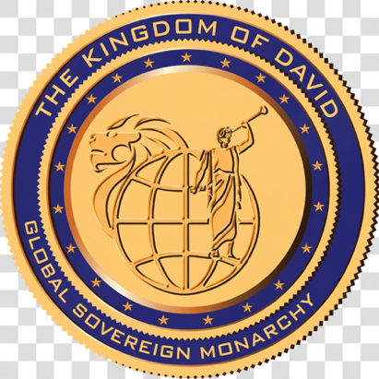
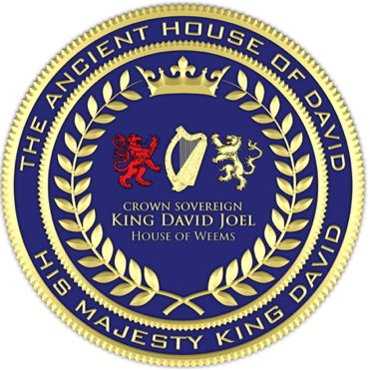


[INTERNATIONAL FLAG OF PEACE] [CROWN SOVEREIGN SEAL] [GREAT SEAL OF THE KINGDOM]

Clerk's Certification and Attestation
I, Vaipuna Alfonso, Presiding Clerk of the Ecumenical and Ecclesiastical Combined Courts, do hereby certify and attest that:
One. The Kingdom Economy of Benevolent Increase has been duly issued under the authority and Royal Prerogative of His Majesty King David Joel, Crown Sovereign of the House and Kingdom of David;
Two. The Kingdom Economy of Benevolent Increase has been properly entered and recorded in the Kingdom Registry of Instruments under Record Number DOCTRINAL-BENEVOLENT-INCREASE-0026-0115-00585;
Three. Registry Entry Identification: DOCTRINAL-BENEVOLENT-INCREASE-0026-0115-00585;
Four. The Kingdom Economy of Benevolent Increase is recorded as official within the Division Four Court of Records of the Ecumenical and Ecclesiastical Combined Courts and is complete, in force, and binding upon all parties noticed herein.
[Signature on the Next Page]


____________________________________ /L.S./
Vaipuna Alfonso
Presiding Clerk — Office of the Clerk, The Ecumenical and Ecclesiastical Combined Courts
Date of Certification: January / 15 / 2026

[CLERK OF COURT SEAL] [COURT SEAL]

Attested: Clerk of Court, EECC, Division Four

