ROYAL MONETARY ACTIVATION ORDER

To legally switch on Acts 200–201 and activate the gold standard
By Royal Command:
- Acts 200–201 of the Royal Constitution are hereby activated in full.
- The Royal Global Bank of Issue is now authorized to issue RGC against audited reserves.
- The Royal Treasury shall denominate all internal accounts in Royal Crowns (paper notes) and RGC.
- All Kingdom projects, contracts, grants, concessions, and public works must use Crowns or RGC.
- Foreign partnership agreements must state conversion terms using RGC as the reference unit.

[Signature and Seal are on the Next Page]
Foundational Maxim of Sovereign Mandate: The Kingdom of David, established by God, and upheld by an eternal and continuing mandate does not seek permission from earthly authorities, but proclaims its mandate and extends invitation to the nations of its peaceful intent to restore the land and its people.

SO DECREED AND ENACTED by His Majesty King David Joel, Crown Sovereign of the House and Kingdom of David, under Royal Seal, as of this Twenty-fifth Day of January, in the Year of Our Lord 2026.
By Royal Prerogative – His Majesty King David Joel

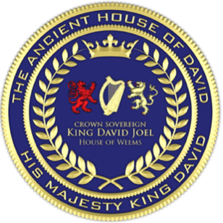
__________________________________
His Majesty King David Joel
Crown Sovereign of the House and Kingdom of David




Clerk's Certification and Attestation
INSTRUMENT: ROYAL MONETARY ACTIVATION ORDER  NO: MAO-EECC-2026-003  JURISDICTION: EECC | STATUS: FORMAL RECORD  CRN-2026-EECC-0220260209-MAO
I, Vaipuna Alfonso, Presiding Clerk of the Ecumenical and Ecclesiastical Combined Courts, do hereby certify and attest that:
One. This official file entitled Royal Monetary Activation Order has been duly issued under the authority and Royal Prerogative of His Majesty King David Joel, Crown Sovereign of the House and Kingdom of David;
Two. This instrument operates under the authority and jurisdiction of the Twelve Combined Courts structure, as formally ratified and confirmed by Royal Sovereign World Notice RC-EECC-2026-012-A;
Three. This instrument has been properly entered and recorded in the Kingdom Registry of Instruments under Court Record Number CRN-2026-EECC-0220260209-MAO;
Four. This instrument is recorded as official within the Division Four Court of Records of the Ecumenical and Ecclesiastical Combined Courts and is complete, in force, and binding upon all parties noticed herein.
Vaipuna Alfonso Presiding Clerk — Office of the Clerk, The Ecumenical and Ecclesiastical Combined Courts
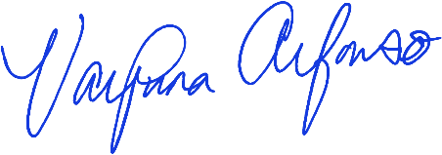
__________________________ /L.S./ Date of Certification: January / 25 / 2026
Vaipuna Alfonso Presiding Clerk —
Office of the Clerk, the
Ecumenical and Ecclesiastical Combined Courts


